7 Colors the Human Eye Can Detect:

1. **RED (magenta)**
2. **YELLOW**
3. **BLUE (cyan)**
4. PURPLE
5. ORANGE
6. GREEN
7. VIOLET *or* INDIGO (indigo)

indigo and violet are different from [purple](http://en.wikipedia.org/wiki/Purple), which cannot be seen on the electromagnetic spectrum but can be achieved by mixing mostly [blue](http://en.wikipedia.org/wiki/Blue) and part [red](http://en.wikipedia.org/wiki/Red) light.

Typically, only features of the composition of [light](http://en.wikipedia.org/wiki/Light) that are detectable by humans (wavelength spectrum from 380 [nm](http://en.wikipedia.org/wiki/Nanometre) to 740 nm, roughly) are included, thereby objectively relating the [psychological](http://en.wikipedia.org/wiki/Psychological) phenomenon of color to its [physical](http://en.wikipedia.org/wiki/Physics) specification. Because perception of color stems from the varying sensitivity of different types of [cone cells](http://en.wikipedia.org/wiki/Cone_cells) in the [retina](http://en.wikipedia.org/wiki/Retina) to different parts of the spectrum, colors may be defined and quantified by the degree to which they stimulate these cells. These physical or [physiological](http://en.wikipedia.org/wiki/Physiological) quantifications of color, however, do not fully explain the [psychophysical](http://en.wikipedia.org/wiki/Psychophysical) perception of color appearance.

|  |  |  |
| --- | --- | --- |
| **The colors of the visible light spectrum**[[2]](http://en.wikipedia.org/wiki/Color#cite_note-1) | | |
| **color** | **wavelength interval** | **frequency interval** |
| [**red**](http://en.wikipedia.org/wiki/Red) | ~ 700–630 nm | ~ 430–480 THz |
| [**orange**](http://en.wikipedia.org/wiki/Orange_%28colour%29) | ~ 630–590 nm | ~ 480–510 THz |
| [**yellow**](http://en.wikipedia.org/wiki/Yellow) | ~ 590–560 nm | ~ 510–540 THz |
| [**green**](http://en.wikipedia.org/wiki/Green) | ~ 560–490 nm | ~ 540–610 THz |
| [**blue**](http://en.wikipedia.org/wiki/Blue) | ~ 490–450 nm | ~ 610–670 THz |
| [**violet**](http://en.wikipedia.org/wiki/Violet_%28color%29) | ~ 450–400 nm | ~ 670–750 THz |

|  |  |  |  |  |  |
| --- | --- | --- | --- | --- | --- |
| **Color, wavelength, frequency and energy of light** | | | | | |
| **Color** | **\lambda \,\!/nm** | **\nu \,\!/1014 Hz** | **\nu_b \,\!/104 cm−1** | **E \,\!/eV** | **E \,\!/kJ mol−1** |
| **Infrared** | >1000 | <3.00 | <1.00 | <1.24 | <120 |
| **Red** | 700 | 4.28 | 1.43 | 1.77 | 171 |
| **Orange** | 620 | 4.84 | 1.61 | 2.00 | 193 |
| **Yellow** | 580 | 5.17 | 1.72 | 2.14 | 206 |
| **Green** | 530 | 5.66 | 1.89 | 2.34 | 226 |
| **Blue** | 470 | 6.38 | 2.13 | 2.64 | 254 |
| **Violet** | 420 | 7.14 | 2.38 | 2.95 | 285 |
| **Near ultraviolet** | 300 | 10.0 | 3.33 | 4.15 | 400 |
| **Far ultraviolet** | <200 | >15.0 | >5.00 | >6.20 | >598 |

http://upload.wikimedia.org/wikipedia/commons/thumb/d/d6/1Mcolors.png/180px-1Mcolors.png

<http://upload.wikimedia.org/wikipedia/commons/d/d6/1Mcolors.png>

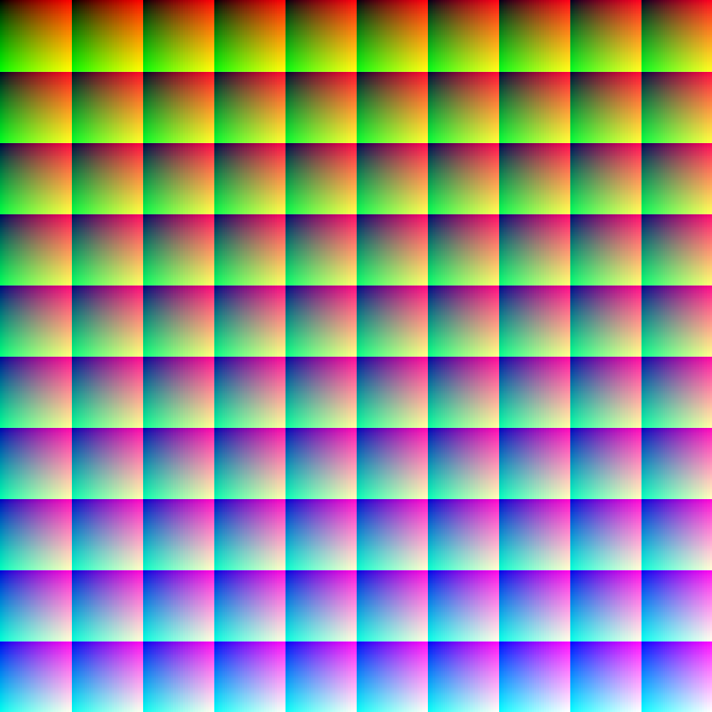

This image (when viewed in full size, 1000 pixels wide) contains 1 million pixels, each of a different color. The human eye can distinguish about 10 million different colors[[5]](http://en.wikipedia.org/wiki/Color#cite_note-business-4)